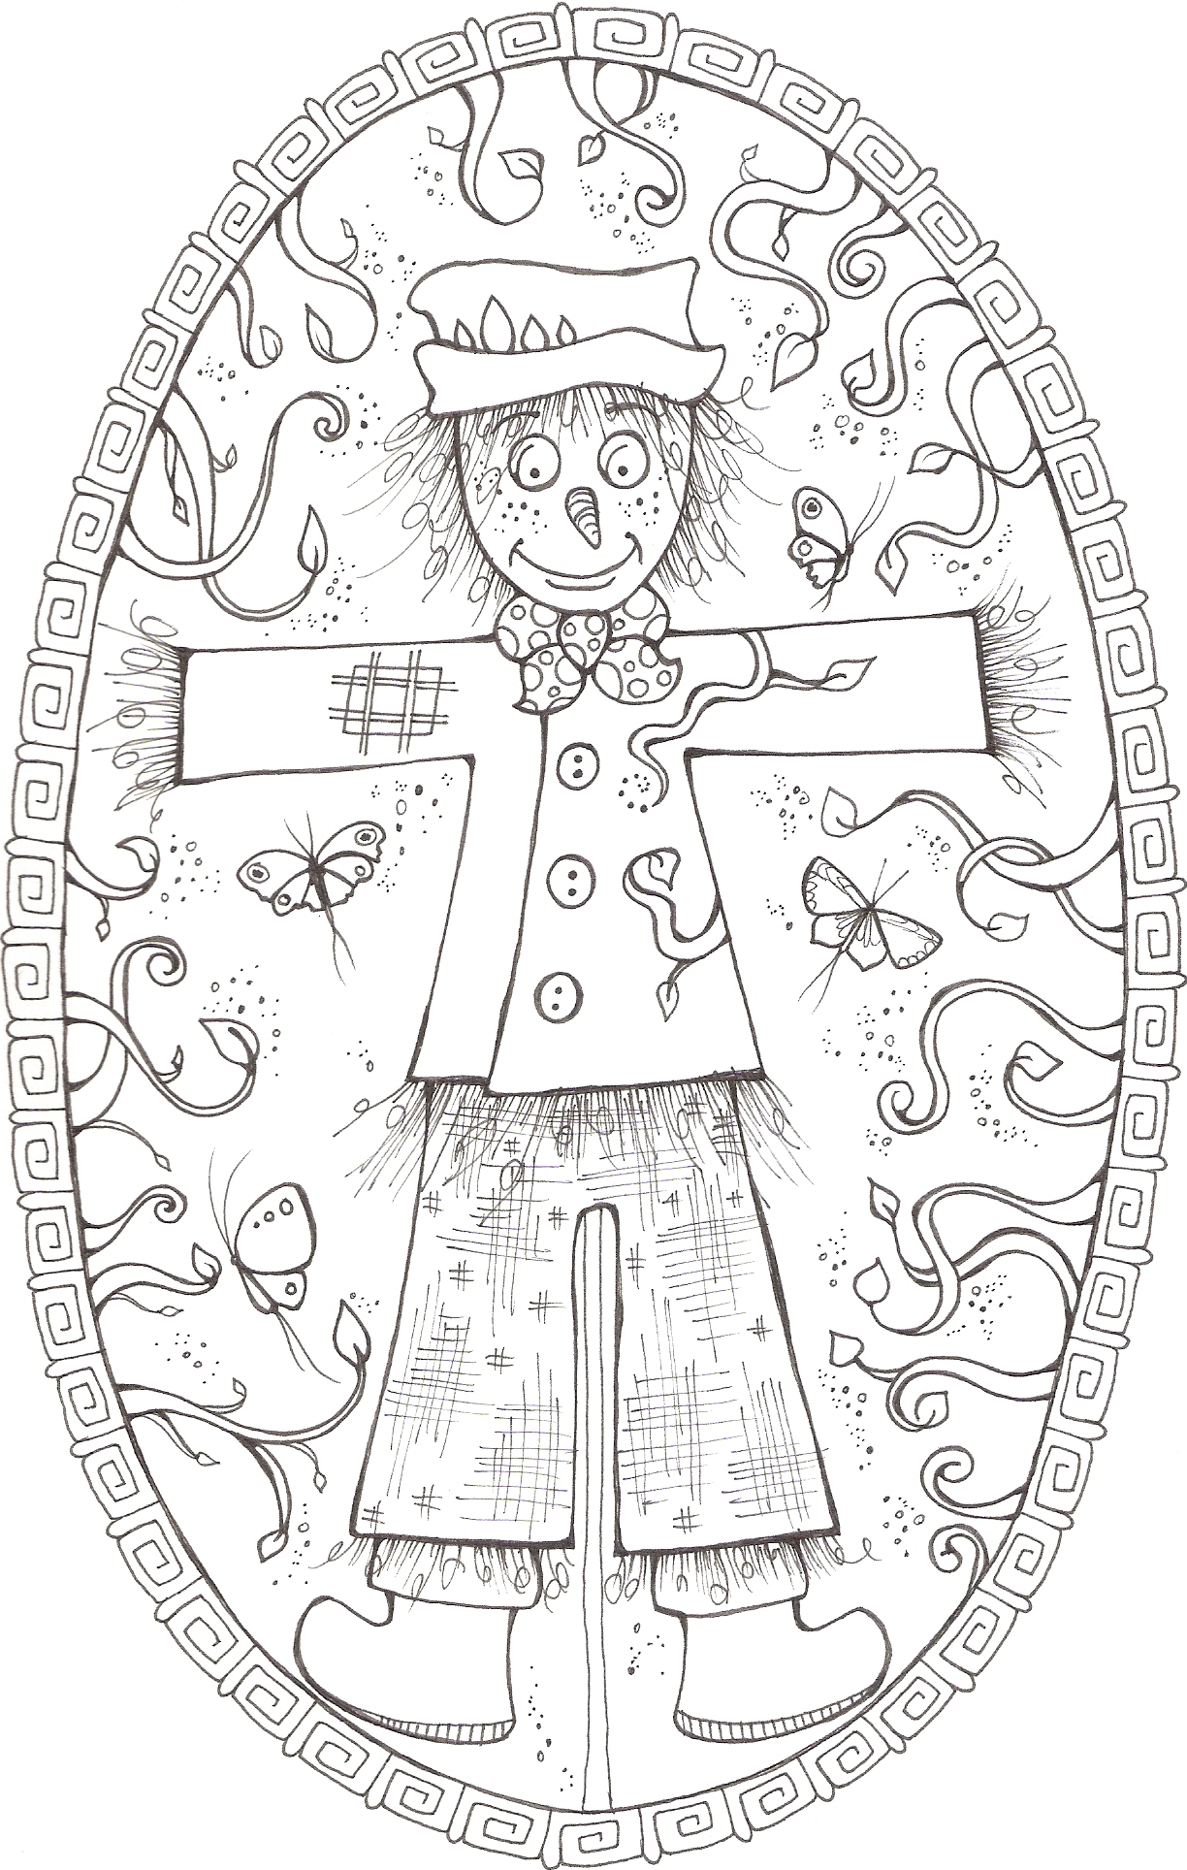©Annie Minnaar 2023 The Tales of Harry Also by Celia Norman Smith www.celianormansmith.co.uk